Serum-sensitivity

Serum-specificity

Serum-Diagnostic accuracy

Serum-Diagnostic accuracy by study design
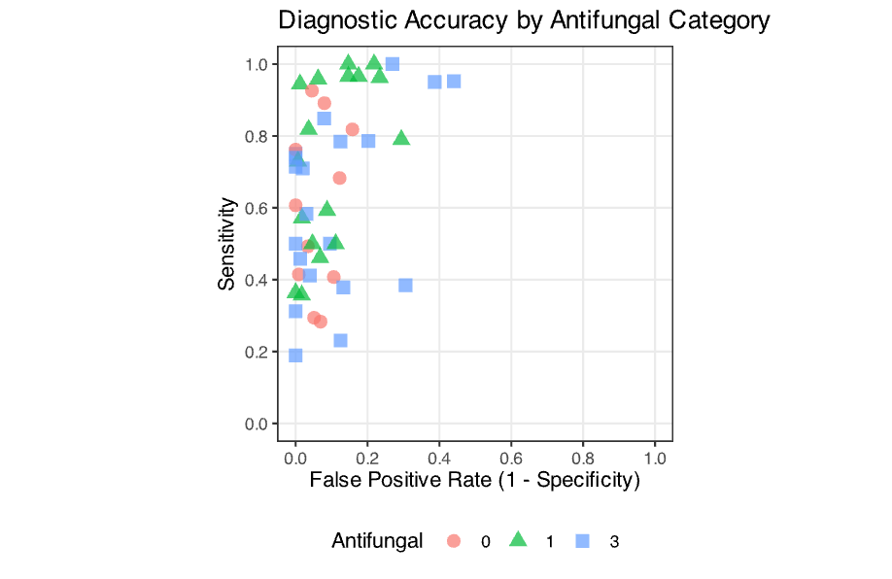
Serum antifungals

Serum no antifungals
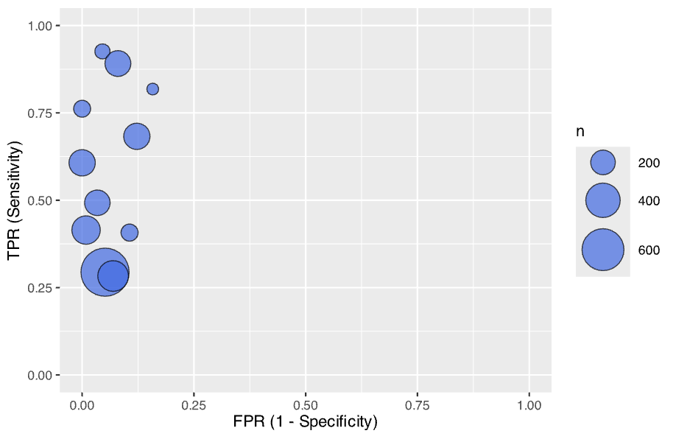
Serum-no antifungals

Serum-on antifungals

BAL results

No antifungals-BAL
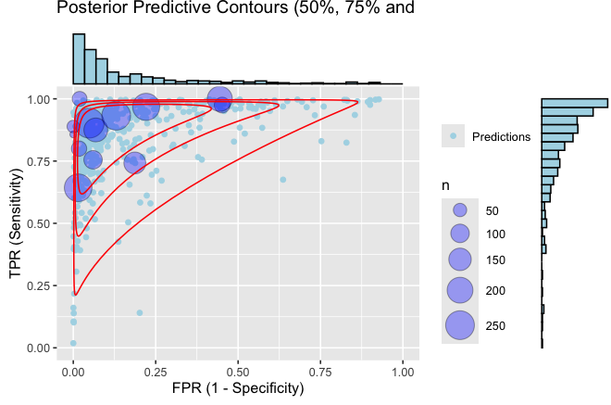
Antifungals-BAL
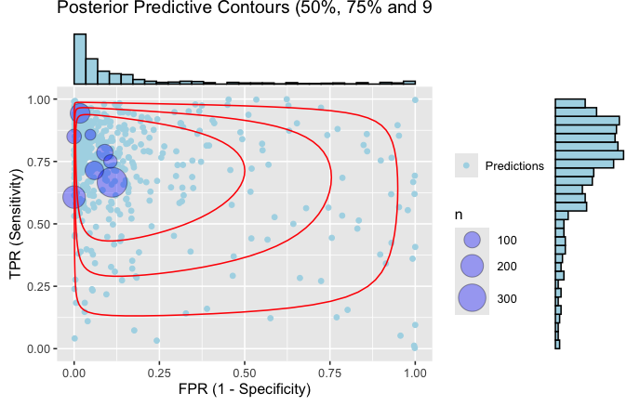
Antifungals- cat 1 & 3
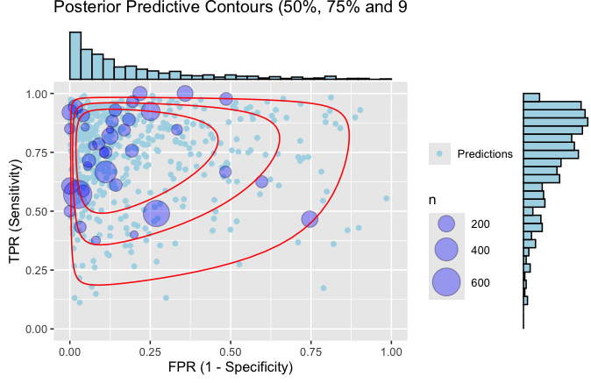

No antifungals-BAL

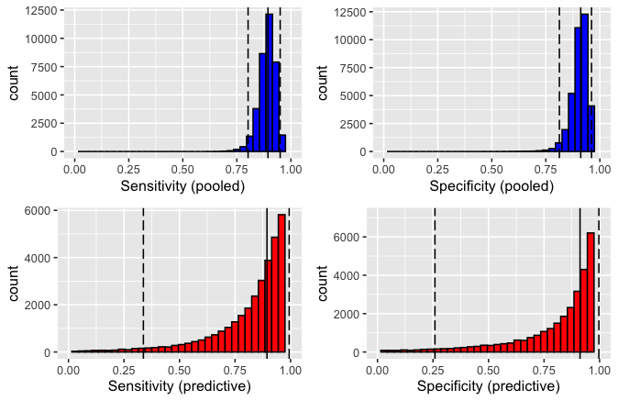
Antifungals-BAL

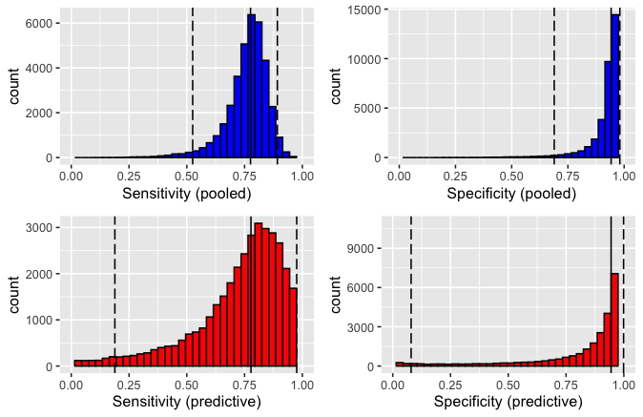
Antifungals cat 1& 3
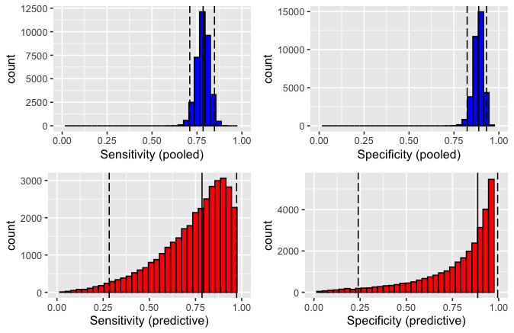

No antifungals-BAL

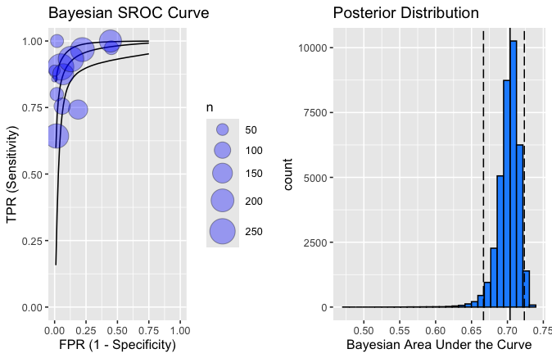
Antifungals
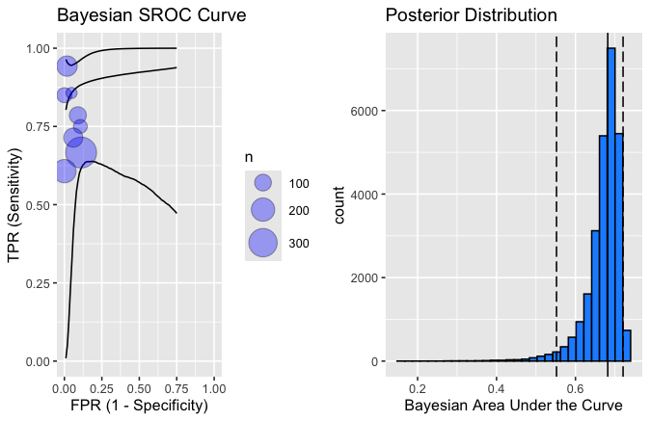
Some- antifungal cat 1&3
